Dear Montana 4-H Club,

Montana Farmers Union (MFU) knows 4-H does a fantastic job of educating youth about farms, ranches, community, and creating future leaders. We do the same thing and that is why MFU wants to send you money to support your efforts!

Simply send us a sentence stating what your club wants money for and you will receive … $100!

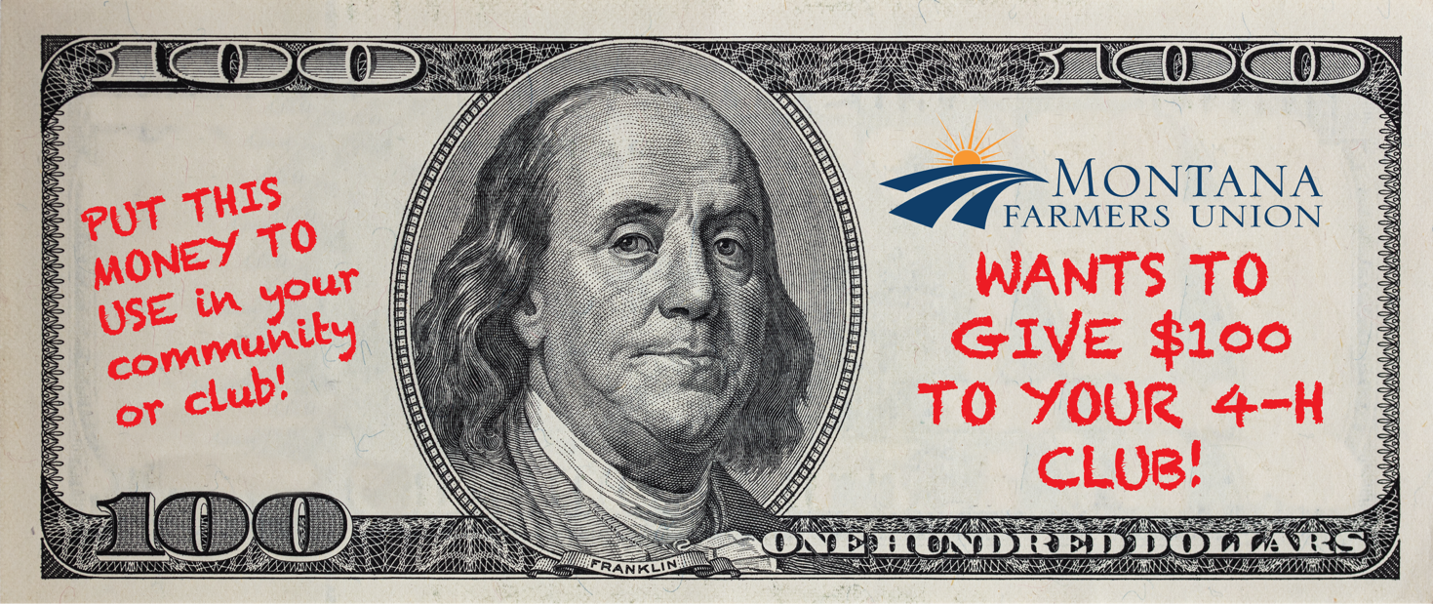

MFU has $10,000 to send to 4-H clubs in Montana. Funding will available until October 1, 2026. Grant application is included with this letter.

Steps to Successful Sentence Grant Completion:
- Since each club can only apply once each year, the sentence for the Grant needs to be discussed and decided on as a club.

Please note, that 4-H Leaders Councils are not eligible for this grant application, but are encouraged to submit for a regular sponsorship request at montanafarmersunion.com/sponsorship

- Have a 4-H member from your club write one sentence below in the designated space, describing what your club needs. It can be as simple as the following examples:

The Constantly Cooking 4-H club wants to make healthier snacks for our meetings and needs money for food. OR As aspiring artists, the members of the Pencil and Pig 4-H club would like to purchase art supplies.

- Then, have a club officer and leader sign the bottom of the application.

4-H member must write the sentence below.

The below signed 4-H Member (preferably a club officer) verifies that they discussed the $100 Sentence Grant Application as a full club and the club has voted and agreed upon the above listed sentence. At least one officer and a club leader need to sign for verification.
Club Officer: _____________________(Print) _________________________(Sign) _______(Date)
Club Leader: _____________________(Print) _________________________(Sign) _______(Date)

Let us know who the Contact and Payee on the check should be. Preferably the check will be sent to your club. If you don’t have a bank account for your club, a 4-H leader may be named as the Payee.
Make check payable to: ________________________________________________________________
Email address of 4-H club or payee contact:_________________________________________________
Phone number of payee contact:__________________________________________________________
County where club is located: ___________________________________________________________
The club or payee mailing address: ________________________________
________________________________
________________________________
Mail this completed application to:
Montana Farmers Union
300 River Drive N, Ste 1
PO Box 2447
Great Falls, MT 59403

Or email a photo/scanned copy of the completed application page to: office@montanafarmersunion.com with “$100 4-H Sentence Grant 2026 – CLUB NAME” in the subject line.

